Power Water Corporation

Asim Quick start manual

A power station simulator

Prepared for Power Water Corporation

By Radical Systems Pty Ltd

# Download ASIM

To download ASIM go to the following URL: <https://github.com/thinkOfaNumber/Asim/releases>. On this page you will need to click the button Asim.msi under the Latest Releases to download the installer file.

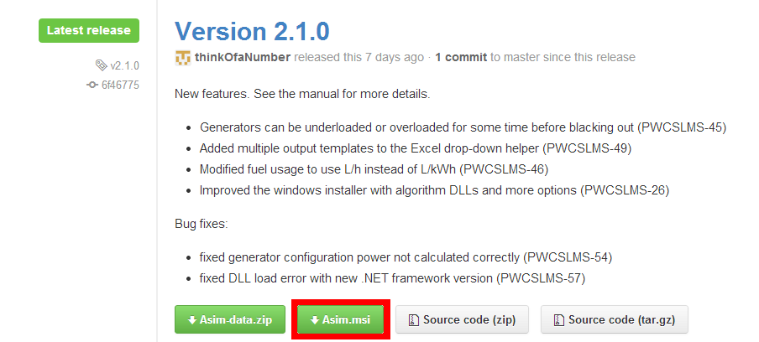

# Installing ASIM

To install ASIM, double click the Asim.msi file (see Download ASIM to retrieve the file) to start the install process.

On the first screen you will need to accept the licence and then choose either Install or Advanced.

* Install
  + This will continue with installing the application.
* Advanced
  + As this application is installed on a per user basis there isn’t an ability to change the install location.
  + On the Product Features screen you will be able to disable/enable whether or not to install the User Manual Information and the additional Algorithms.

Once the application has been installed you will have the option to view the ReadMe. To do this check the ‘View the Readme’ checkbox before clicking the Finish button.

When the Finish button is clicked, if the ‘View the Readme’ checkbox was checked, then the ReadMe will be opened. The folder in which the application was installed will also be opened.

# Sample Documents

There are several sample files which can be used to get you started with the ASIM application and can be located at the following location ‘Install Directory\Samples’.  
The first document is the example.xls or example.xlsx, which is used to configure and run the application.  
The other document is the load.csv which contains sample load data, this will need to be extracted from the zip before being used.

# Enabling the ASIM Macro

1. Open Microsoft Excel
2. Enable the Macro in Excel. This depends on your Excel version.
   1. In Excel 2007 and earlier, From the Tools menu, choose Add-Ins…
   2. 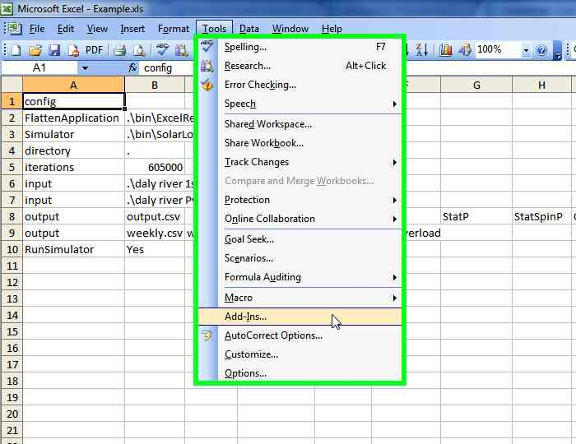In Excel 2010 and later, From the File menu, choose Options, then select Add-Ins, then press the “Go” button next to Manage Excel Add-Ins

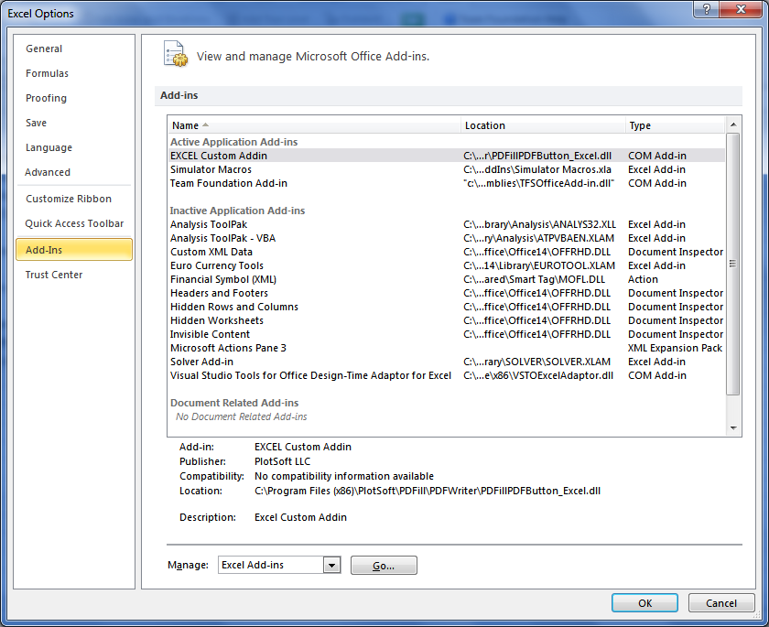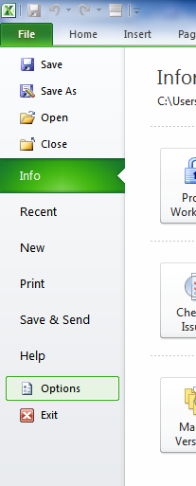

1. For all versions of Excel, In the list, select “Asim Addin” and click OK.   
   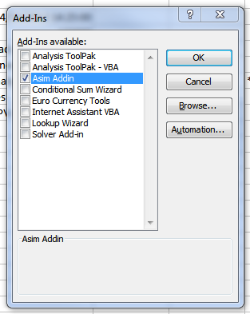

You should now have a new menu bar called “Asim”.   
In Excel 2010, this is under the Add-Ins ribbon heading.

# Running the Simulator

The following steps will allow you to perform a basic run of the simulator so that you gain an idea of what output will be generated from the simulator.

1. Open
   1. If you are using Excel 2003 then open example.xls
   2. If you are using Excel 2007 or later then open example.xlsx
2. Ensure that you have followed the steps in Enabling the ASIM Macro
3. Ensure that the Load.csv file has been extracted from the Load.zip file.
4. To run the application you will need to navigate to the Asim Menu -> Run Application. This depends upon your version of Excel version.
   1. In 2003 there will be a new toolbar menu item called Asim. 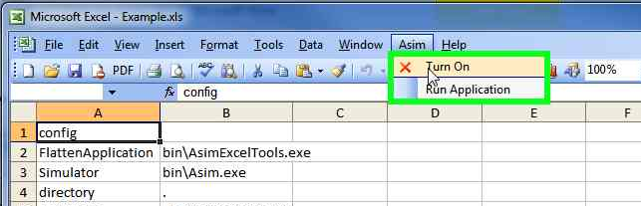
   2. In 2007 or later you will need to navigate to the ADD-INS ribbon option to then find the Asim menu. 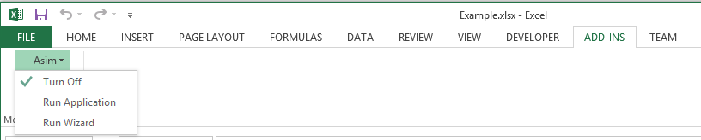
5. Once you click ‘Run Application’ a Command Window will open to start performing the simulation.
6. Once the simulation has been completed you will notice that there have been a number of files that have been created in the same folder as the Example spreadsheet.
   1. The documents prefixed with example_ have been extracted from the Example file and used to perform the simulation.
   2. The analyse.csv is the results for the simulation that has just been performed.
7. You can now use the analyse.csv file in your desired graphing application.

# More Configuration Information

For more information on how to configure the spreadsheet and all the tabs, please read the ‘Reference Manual.pdf’, which is located at ‘Install Directory\Docs’.